Question 1

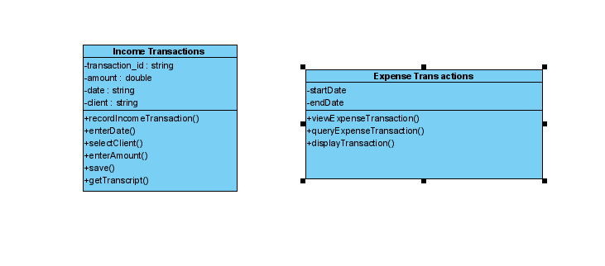

Question 2

Income transaction sequence diagram

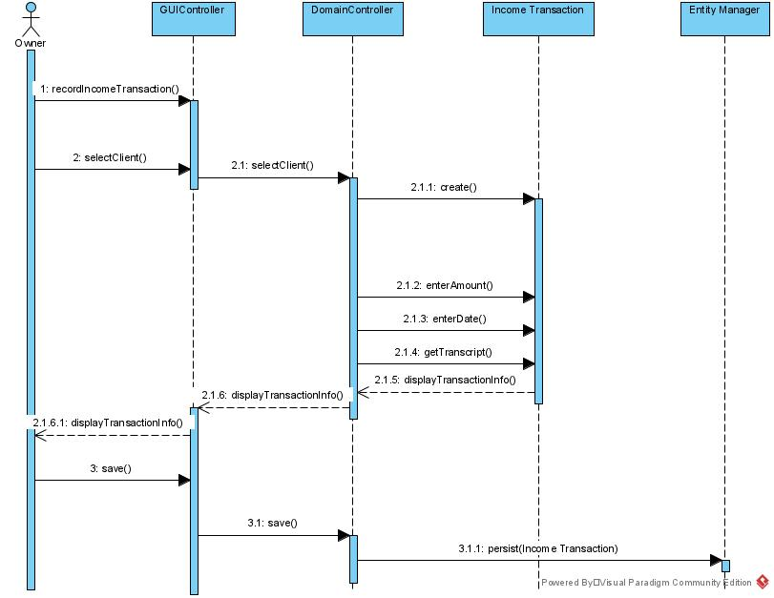

Expenses transaction Sequence Diagram

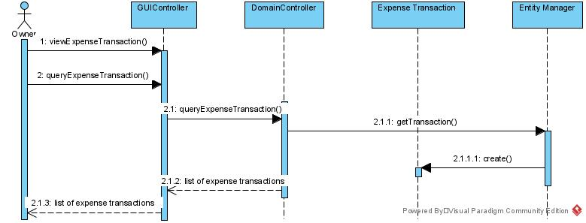

**Question 3**

Using manual means to scan invoices can be tiresome. As a requirement in our model, Brad could use electronic scanner. Consequently, they name each of the invoices with a unique order number. Other details about the supplier and exact transaction details, will obviously be automatically fetched and stored. To electronically locate the documents for each expense, Brad will search each transaction with its unique id or even order number.

**Question 4**

Tax implications refer to the deductions that are related to the expenses one incurs while maintaining investment properties.

This affects the model as it can reduce the profit and also reduce your taxable income.

**Question 5**

Brad could enhance his business to have global reach. To support this, he could take payment via credit card such as Visa and MasterCard where the client will also pay foreign conversion fee.

**Question 6**

While avoiding tax is legal, paying through cash won’t mean that he can avoid paying tax. This is a good idea for Brad since he can save money and be able to make fewer impulse purchases. This also makes it easier for brad to budget. The clients can be able to get cash discounts easily through cash payment and avoid transaction fees involved in other payment methods.

**Question 7**

Agile Methodology would suite brad better. This is because rapid and continuous delivery of useful software would ensure satisfaction of the customers wile active interaction between developers, customers and testers is there.